# Computer Hardware Exploration

**Score:**

Minus: Points: Letter Grade:

— ---------

22

Name: Click here to enter text.

Period: Click here to enter text.

PC #: Click here to enter text.

Use either your home computer or the school computer if you do not have one at home and answer the following questions.

1. Circle: Home  / School Computer
2. With what brand of computer are you working?

Brand Click here to enter text.

1. List all the peripheral that are connected to your computer and then mark them as input/output/storage - please write as many as you can.

**Peripheral Device**  **Input/Output/Storage**

1. Click here to enter text. Click here to enter text.
2. Click here to enter text. Click here to enter text.
3. Click here to enter text. Click here to enter text.
4. Click here to enter text. Click here to enter text.
5. Click here to enter text. Click here to enter text.
6. Click here to enter text. Click here to enter text.
7. Click here to enter text. Click here to enter text.

Label every peripheral device (mouse, monitor, CD-ROM, etc…) pictured. Follow the lines to see what it is really pointing to.

**Desktop Computer**

4. Click here to enter text.

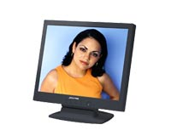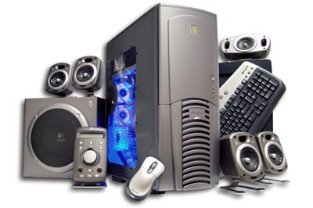

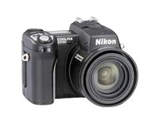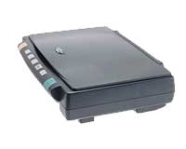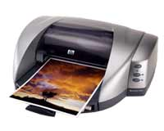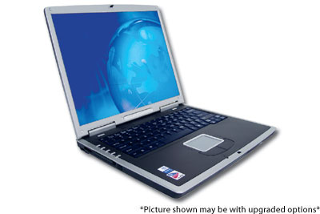 5. Click here to enter text.

6. Click here to enter text.

7. Click here to enter text. 8. Click here to enter text.

**Laptop Computer**

1337 10. Click here to enter text.

9. Click here to enter text.

11. Click here to enter text.

12. Click here to enter text.

13. Click here to enter text.

14. Click here to enter text.

Compare desktop and laptop computers, based on your knowledge answer the following questions. (do not use the same thing stated 2 different ways)

Name 3 ways desktops and laptops are similar.

15. Click here to enter text.

16. Click here to enter text.

17. Click here to enter text.

Name 3 ways desktops and laptops are different   
(do not restate the same difference twice).

18. Click here to enter text.

19. Click here to enter text.

20. Click here to enter text.

1. Under what situation are you more likely going to want to use a laptop computer & why? (Put both responses in proper sentence format)

I would prefer to use a laptop computer when I am: Click here to enter text.

Because: Click here to enter text.

1. Under what situation are you more likely going to want to use a desktop computer & why? (Put both responses in proper sentence format)

I would prefer to use a desktop computer when I am: Click here to enter text.

Because: Click here to enter text.