Name
Period #
Computer #
Will the Software Work?

Compare the computers and their system specs with the software titles and their listed system requirements.

Tell which software titles will play on a specific computer by stating “yes” for it will work or “no” it will not work.

Make sure the computer meets or exceeds ALL of the minimum requirements.

If the computer does not meet or exceed even one requirement of the software, you must answer no.

Put an X through the software requirements that are not met by the PC.

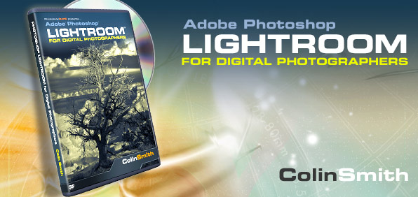
One X is enough to mark the software as “No” it will not work.

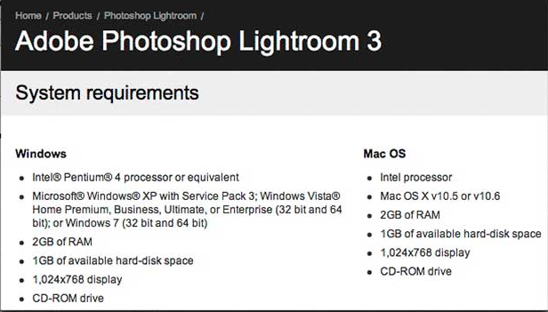

Computer A: 2001 Dell Optiplex 520 (Student Computers found around building)

Name | RAM | CD/DVD | Processor | Processor Speed | Operating System
Dell Optiplex 520 | 512 MB Ram | CD Drive | Pentium 4 | 1.6 GHz  (1600 MHz) | Windows 2000

Will this software work on Computer A? Write Yes or No in the correct box.

Name | Operating System | Processor | Processor Speed | RAM | CD/DVD | Does it Work?
Quicken 2012 | Windows XP, Vista, 7 | Pentium 3 or newer | 1 GHz  (1000 MHz) | 1 GB (1000 MB) | CD
Elder Scrolls V: Skyrim | Windows 7, Vista, XP | Quad Core or better | 2.0 GHz  (2000 MHz) | 4 GB | DVD or Internet
Battlefield 3 | Windows XP, Vista, 7 | Core 2 Duo or better | 2.0 GHz  (2000 MHz) | 2 GB | DVD
Final Cut 4 | Mac OS X | PowerPC, G4, G5, Core Duo or newer | 1.25 GHz  (1250 MHz) | 1 GB Ram  (1000 MB) | DVD
JumpStart Artist | Windows 2000, XP | Pentium 2 or newer | 266 MHz | 64 MB RAM | CD
Office 2010 | Windows XP, Server 2003, Server 2008 Vista, 7 | Pentium 1 or newer | 500 MHz | 512 MB RAM | CD
Adobe Creative Suite 5 | Windows XP, Vista, 7 | Quad Core or newer | 2 GHz  (2000 MHz) | 4 GB  (4000 MB) | DVD
World of Warcraft – Cataclysm | Windows XP, Vista, 7, Mac OS X | Intel Pentium 4 or better | 1.3 GHz 1300 MHz) | 1 GB  (1000 MB) | DVD
iLife | Mac OS X | Core Duo or better | 1 GHz  (1000 MHz) | 1 GB  (1000 MB0 | DVD

Computer B: Dell Optiplex 745 (the computer in front of you)

Name | RAM | CD/DVD | Processor | Processor Speed | Operating System
Dell Optiplex 745 | 2 GB RAM  (2000 MB) | DVD Drive | Core Duo | 1.8 GHz  (1800 MHz) | Windows XP

Will this software work on Computer B? Write Yes or No in the correct box.

Name | Operating System | Processor | Processor Speed | RAM | CD/DVD | Does it Work?
Quicken 2012 | Windows XP, Vista, 7 | Pentium 3 or newer | 1 GHz  (1000 MHz) | 1 GB (1000 MB) | CD
Elder Scrolls V: Skyrim | Windows 7, Vista, XP | Quad Core or better | 2.0 GHz  (2000 MHz) | 4 GB | DVD or Internet
Battlefield 3 | Windows XP, Vista, 7 | Core 2 Duo or better | 2.0 GHz  (2000 MHz) | 2 GB | DVD
Final Cut 4 | Mac OS X | PowerPC, G4, G5, Core Duo or newer | 1.25 GHz  (1250 MHz) | 1 GB Ram  (1000 MB) | DVD
JumpStart Artist | Windows 2000, XP | Pentium 2 or newer | 266 MHz | 64 MB RAM | CD
Office 2010 | Windows XP, Server 2003, Server 2008 Vista, 7 | Pentium 1 or newer | 500 MHz | 512 MB RAM | CD
Adobe Creative Suite 5 | Windows XP, Vista, 7 | Quad Core or newer | 2 GHz  (2000 MHz) | 4 GB  (4000 MB) | DVD
World of Warcraft – Cataclysm | Windows XP, Vista, 7, Mac OS X | Intel Pentium 4 or better | 1.3 GHz 1300 MHz) | 1 GB  (1000 MB) | DVD
iLife | Mac OS X | Core Duo or better | 1 GHz  (1000 MHz) | 1 GB  (1000 MB0 | DVD

Computer C: Mr. Myers’s Acer Aspire 5742 Laptop

Name | RAM | CD/DVD | Processor | Processor Speed | Operating System
Acer Aspire 5742 | 4 GB RAM  (4000 MB RAM) | DVD Drive | i3 Dual Core  64-bit OS | 2.40 GHz  (3200 MHz) | Windows 7  Home Premium

Will this software work on Computer C? Write Yes or No in the correct box.

Name | Operating System | Processor | Processor Speed | RAM | CD/DVD | Does it Work?
Quicken 2012 | Windows XP, Vista, 7 | Pentium 3 or newer | 1 GHz  (1000 MHz) | 1 GB (1000 MB) | CD
Elder Scrolls V: Skyrim | Windows 7, Vista, XP | Quad Core or better | 2.0 GHz  (2000 MHz) | 4 GB | DVD or Internet
Battlefield 3 | Windows XP, Vista, 7 | Core 2 Duo or better | 2.0 GHz  (2000 MHz) | 2 GB | DVD
Final Cut 4 | Mac OS X | PowerPC, G4, G5, Core Duo or newer | 1.25 GHz  (1250 MHz) | 1 GB Ram  (1000 MB) | DVD
JumpStart Artist | Windows 2000, XP | Pentium 2 or newer | 266 MHz | 64 MB RAM | CD
Office 2010 | Windows XP, Server 2003, Server 2008 Vista, 7 | Pentium 1 or newer | 500 MHz | 512 MB RAM | CD
Adobe Creative Suite 5 | Windows XP, Vista, 7 | Quad Core or newer | 2 GHz  (2000 MHz) | 4 GB  (4000 MB) | DVD
World of Warcraft – Cataclysm | Windows XP, Vista, 7, Mac OS X | Intel Pentium 4 or better | 1.3 GHz 1300 MHz) | 1 GB  (1000 MB) | DVD
iLife | Mac OS X | Core Duo or better | 1 GHz  (1000 MHz) | 1 GB  (1000 MB0 | DVD

Computer D: 15” MacBook Pro (a random apple computer)

Name | RAM | CD/DVD | Processor | Processor Speed | Operating System
15” MacBook Pro | 4 GB RAM  (4000 MB) | DVD Drive | Core i7 | 2.2 GHz  (2200 MHz) | Mac OS X

Will this software work on Computer A? Write Yes or No in the correct box.

Name | Operating System | Processor | Processor Speed | RAM | CD/DVD | Does it Work?
Quicken 2012 | Windows XP, Vista, 7 | Pentium 3 or newer | 1 GHz  (1000 MHz) | 1 GB (1000 MB) | CD
Elder Scrolls V: Skyrim | Windows 7, Vista, XP | Quad Core or better | 2.0 GHz  (2000 MHz) | 4 GB | DVD or Internet
Battlefield 3 | Windows XP, Vista, 7 | Core 2 Duo or better | 2.0 GHz  (2000 MHz) | 2 GB | DVD
Final Cut 4 | Mac OS X | PowerPC, G4, G5, Core Duo or newer | 1.25 GHz  (1250 MHz) | 1 GB Ram  (1000 MB) | DVD
JumpStart Artist | Windows 2000, XP | Pentium 2 or newer | 266 MHz | 64 MB RAM | CD
Office 2010 | Windows XP, Server 2003, Server 2008 Vista, 7 | Pentium 1 or newer | 500 MHz | 512 MB RAM | CD
Adobe Creative Suite 5 | Windows XP, Vista, 7 | Quad Core or newer | 2 GHz  (2000 MHz) | 4 GB  (4000 MB) | DVD
World of Warcraft – Cataclysm | Windows XP, Vista, 7, Mac OS X | Intel Pentium 4 or better | 1.3 GHz 1300 MHz) | 1 GB  (1000 MB) | DVD
iLife | Mac OS X | Core Duo or better | 1 GHz  (1000 MHz) | 1 GB  (1000 MB0 | DVD

The Breakdown of Oldest (top) to Newest (bottom)

Use this chart to see what newer means when this is mentioned for software’s minimum requirements.

Windows OS | Macintosh OS | Intel Processors | Mac Processors
DOS | Mac OS 1 |  | Motorola 68040
Windows 1 | Mac OS 2 | 80486SL | PowerPC 601
Windows 2 | Mac OS 3 | Pentium 1 | PowerPC 603
Windows 3 | Mac OS 4 | Pentium 2 | PowerPC 604
Windows 95 | Mac OS 5 | Pentium 3 | PowerPC G3
Windows 98 | Mac OS 6 | Pentium 4 | PowerPC G4
Windows 2000 | Mac OS 7 | Core Duo | PowerPC G5
Windows XP | Mac OS 8 | Core 2 Duo
Windows Vista | Mac OS 9 | Quad Core
Windows 7 | Mac OS X (10) | i7, i5, i3

